Web Shooters: A Biometric approach to Wrist-mounting Web deploying Technology

Executive summary: The project proposes the design, prototyping, and development, of a wrist mounted device that is capable of deploying web like material at high speed. This project is going to mimic the web shooters used by the fictional character “Amazing Spiderman”, and will use fluid mechanics to deploy it.

Objectives
- Design a small, wrist mounting launching mechanism.
- Develop synthetic web material with decent enough strength and adhesion.
- Create a trigger mechanism for rapid deployment.
- Ensure safety and reusability of the system
- (optional goal): Test for strength for object retrieval
Sketches: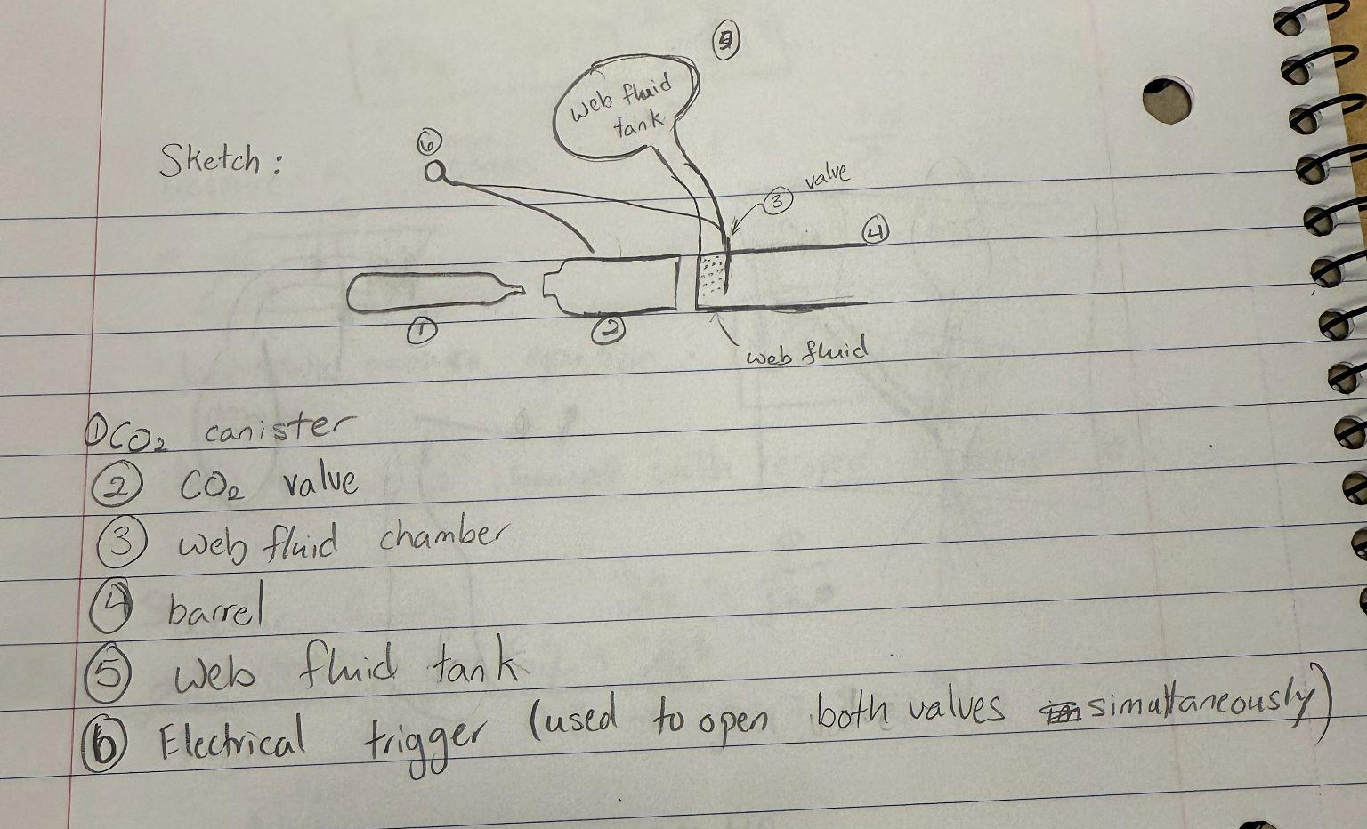

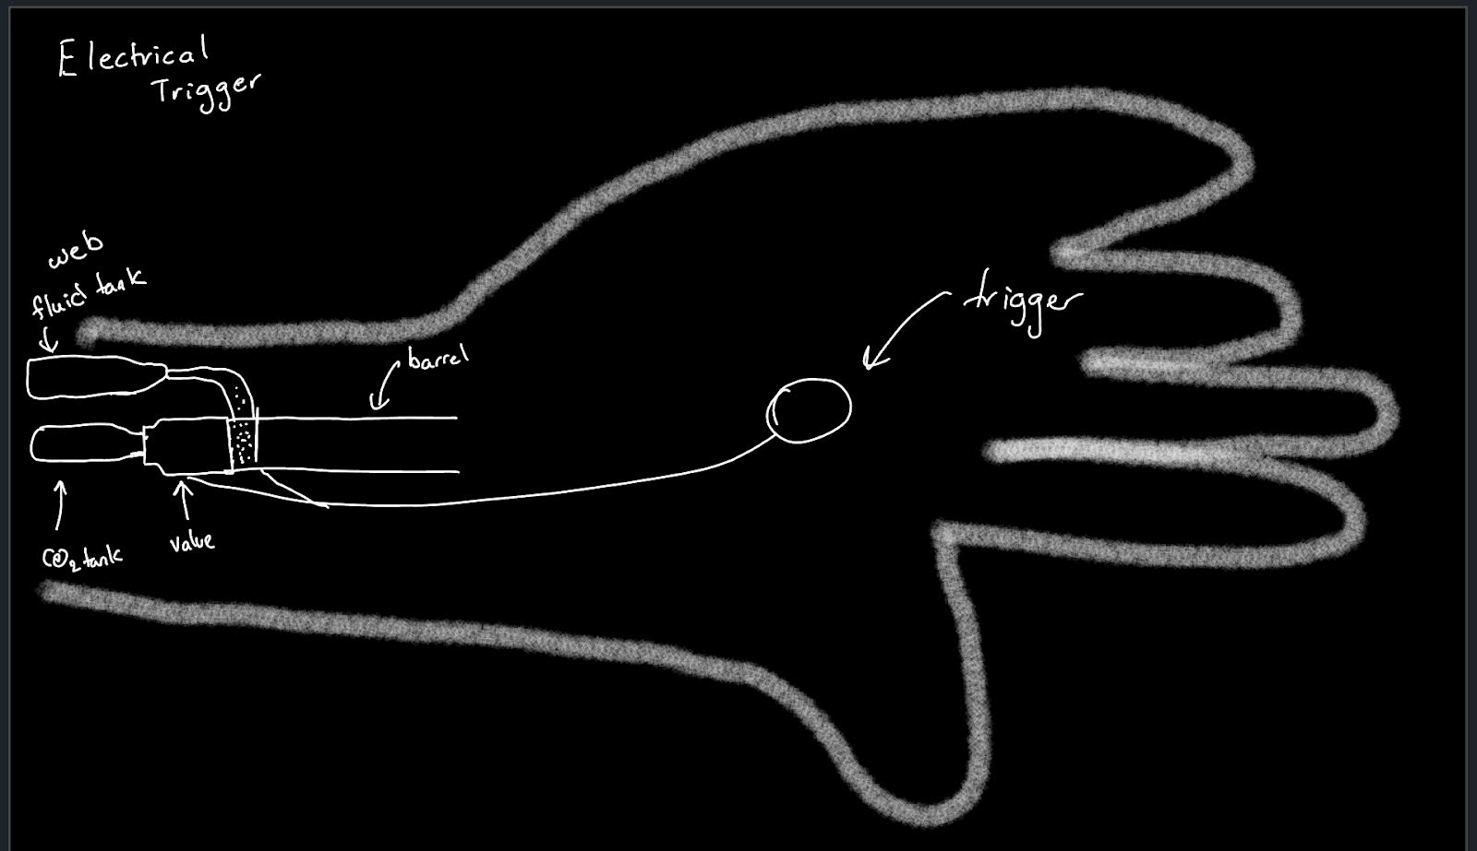
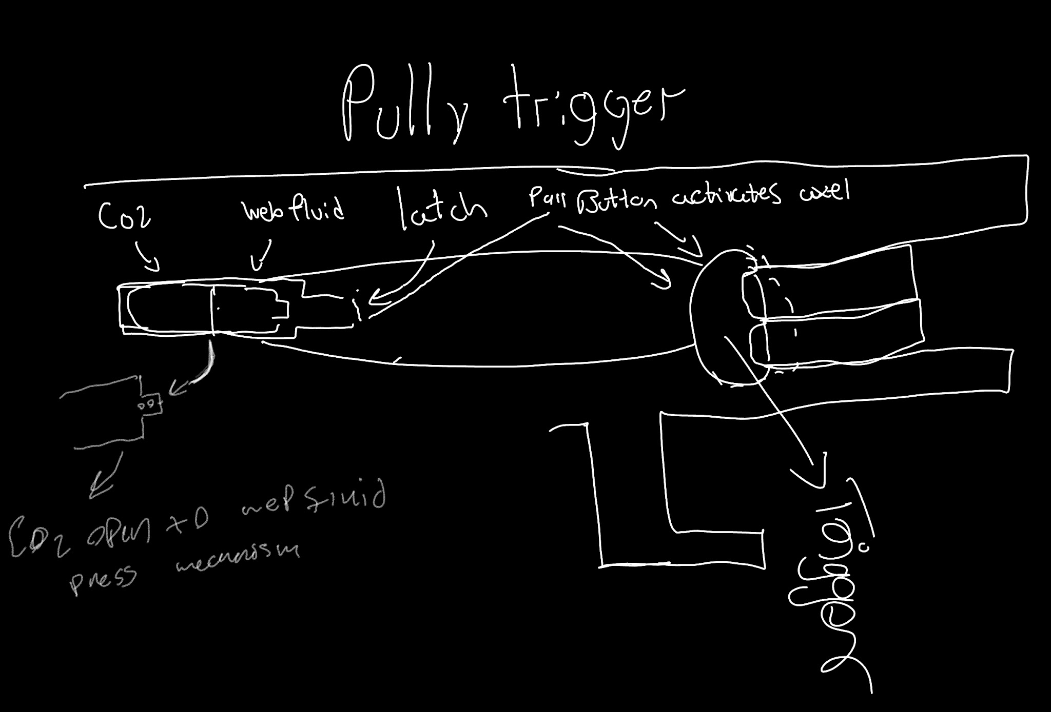

Web Fluid Ingredients:
- Acetone/Ethanol
- Polymethyl Methacylate Powder (PMMA Powder)
- Water
- Polyvinyl Acetate

Materials for First Purchase
- All the ingredients for the Web fluid
- CO2 Cansters
- Butane pen
- Beakers
- Cardboard
- Handheld spray bottle
- Syringes

Plan of Action
- Purchase Materials
- Make web fluid
- make sure there is enough pressure in the CO2 can
- make sure the trigger system is stable
- Find out if it’s possible to make it shoot the CO2 into the web fluid multilevel times without refilling.
- Finalize design
- Build Prototype
- Purchase Materials
- Redesign
- go through step 2-5
- Build Final Project

